

Home Kitchen

Project Planning

Team Lead: Ayesha Tahreem Aamir 14L-4473

Members: Hafiza Ramzah Rehman 14L-4342

Mahnoor Fatima 14L-4293

Sana Fatima 14L-4079

Muhammad Bilal Zubairy

Date: 3rd October 2017

National University of Computer and Emerging Sciences

Department of Computer Science

Lahore, Pakistan

Work Breakdown Structure (WBS)

Following is the screenshot of WBS (Work Breakdown Structure) of our project “HomeKitchen”:

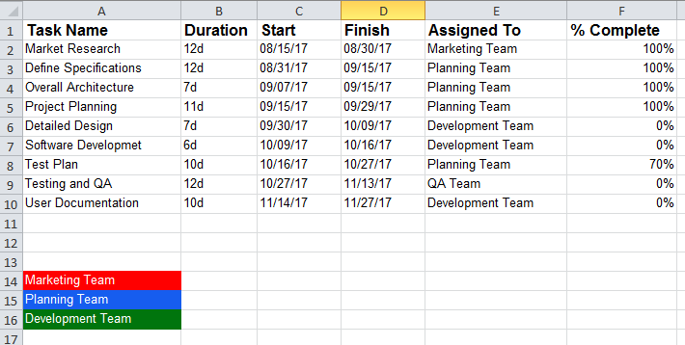

Gantt Chart

Following is the screenshot of Gantt Chart obtained after WBS (Work Breakdown Structure) of our project “HomeKitchen”:

